Block: A Room: 2408
Social Studies 9

Ms. McMillan
Email: jmcmillan@deltasd.bc.ca
Website: msjmcmillan.weebly.com
Office Hours: (By appointment) Day 1 & 3 after school and Flex Time

The Course at a glance:
Social Studies 9 covers the time period from 1750 – 1914, and is based upon the following big ideas:
- Emerging ideas and ideologies profoundly influence societies and events
- The physical environment influences the nature of political, social, and economic change.
- Disparities in power alter the balance of relationships between individuals and between societies.
- Collective identity is constructed and can change over time.
We will examine identity, society and culture, government structures, the economy, and the environment in this time period, while also making connections to the present. The goal is that students will have a better understanding the complexities of our nation today by learning about its past.

Expectations:
As a class, we will develop a set of classroom expectations that ensure all members of our class are treated with respect. Above all, it is extremely important that you show up to class, and hand in your assignments on time; this is the best way to guarantee your success.

Cell Phones:
When you arrive in class, all cell phones must be place in the cell phone storage holder on the wall. Each student will be assigned a numbered pocket to keep their phone in for the year. The phones will stay here for the entire class, unless Ms. McMillan allows time to use them. The phones will visible at all times, therefore, students leave them at their own risk. If you do not want to put your phone in the classroom storage, then you must leave your phone in your locker.

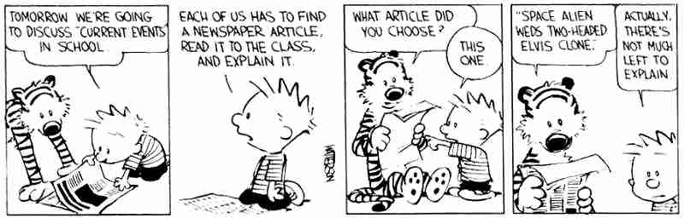

Homework and Assignments:
All homework and assignments must be in on time unless you have spoken with me in advance and have a legitimate reason. If you miss an assignment deadline, you must talk to me immediately. The only way to make up the assignment is to come in during flex time to complete it with Mrs. McMillan – NO EXCEPTIONS! Late marks will not be taken off as long as you complete the assignment in front of me. Missing assignments are the #1 reason for not completing a course!

How to get extra help:
Please make sure you ask questions and get extra help if you need it. Don’t wait until the end of the year.
- Check the class website to catch up: msjmcmillan.weebly.com
- Check assignments regularly on Student Connect: https://cimsweb.deltasd.bc.ca
- Email Mrs. McMillan at jmcmillan@deltasd.bc.ca to ask a question or book an appointment.
- See Mrs. McMillan during Flex Time and/or after school on days 1/3 to get help or make up missed assignments.

Major Units:
Personal Family history / Geography, Environment and Economy of Canada / Indigenous Peoples of Canada / Revolution (American, French and other) / Canadian Confederation / Development of Canada

Supplies and Texts: *Always come to class with ALL supplies and texts!!!
Required Supplies
2 inch binder
lined paper
dividers
pens and pencils
eraser and whiteout
pencil crayons
It is your responsibility to have all required supplies by the second meeting of this class. Throughout the year students will use two texts: Crossroads and Horizons. The textbooks will be signed out in your name and therefore need to be returned in the same condition. (If they are not returned students will be charged for damaged or lost books).

Assessment:
You will be continually assessed throughout the year in a variety of ways. All tasks and assignments will be handed out with an assessment rubric like the one below. When students hand in assignments they will also hand in the rubric and self-asses. The rubric will then be handed back with the final mark.

Exemplary  A  (100 – 86) | Accomplished  B  (85 – 73) | Developing  +C-  (72 – 50) | Beginning  I / F  (49 – 0)
-Consistently exceptional in all areas  -Above and beyond standards | -Good in all areas  -Consistently meets standards | -Average  -Meets some standards but not others | -below averages  -Unexcused absences and/or missing assignments or performances

