English 9
Blocks: E/G Room: 2724
Mrs. McMillan
Email: jmcmillan@deltasd.bc.ca
Website: msjmcmillan.weebly.com
2017-2018

The Course at a glance:
English 9 is based upon the following big ideas:
- Language and story can be a source of creativity and joy.
- Exploring stories and other texts helps us understand ourselves and make connections to others and the world.
- People understand text differently depending on their worldviews and perspectives.
- Texts are socially, culturally, and historically constructed.
- Questioning what we hear, read, and view contributes to our ability to be educated and engaged citizens.
Throughout the year we will explore a variety of short stories, novels, poetry, grammar, oral storytelling, writing skills and Shakespeare in order to develop these big ideas.

Expectations:
As a class we will develop a set of classroom expectations that ensure all members of our class are treated with respect. Above all, it is extremely important that you show up to class, and hand your assignments in on time; this is the best way to guarantee your success in this class.

Homework and Assignments:
All homework and assignments must be in on time unless you have spoken with me in advance and have a legitimate reason. If you miss an assignment deadline, you must talk to me immediately. The only way to make up the assignment is to come in after school and complete it with Mrs. McMillan – NO EXCEPTIONS! Late marks will not be taken off as long as you complete the assignment in front of me. Missing assignments are the #1 reason for not completing a course!

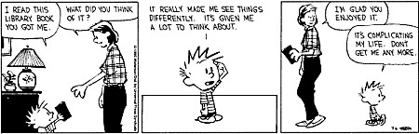
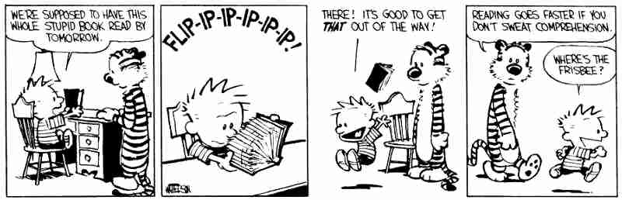
How to get extra help:
Please make sure you ask questions and get extra help if you need it. Don’t wait until the end of the year.
- Check the class website to catch up: msjbennett.weebly.com
- Check your assignments regularly on Student Connect: https://cimsweb.deltasd.bc.ca
- Email Mrs. McMillan at jmcmillan@deltasd.bc.ca to ask a question or book an appointment.
- See Mrs. McMillan after school on day 2/4 to get help and/or make up missed assignments.

Supplies and Texts: ***Always come to class with ALL supplies and texts***
Required Supplies:
- 2 inch binder
- lined paper
- dividers (7)
- pens and pencils
- eraser and whiteout
- pencil crayons (optional)

It is your responsibility to have all required supplies by the second meeting of this class. Texts will be assigned to students as needed. These textbooks will be signed out in your name and therefore need to be returned in the same condition. If they are not returned students will be charged for damaged or lost books.

Dividers: Please set up your binder with the following dividers:
Grammar, Writing, Short Stories, Novel, PEP, Poetry and Shakespeare. The rest will be assigned throughout the year.

Personal Enrichment Project:
Each year, English students at DSS participate in the Personal Enrichment Project. Students select a classic novel (from a list of suggestions) to read throughout the year, and participate in a year-end discussion and assessment. Students are expected to purchase a copy of their book for the year. Please let Mrs. McMillan know if this is not possible.

Assessment:
You will be continually assessed throughout the year in a variety of ways. On your report card you will receive an overall percentage/letter grade and a work habits mark based on the following:

Overall percentage/letter grade | Work habits
- Assignments (individual & group)  - Writing skills & Reading comprehension  - Tests and final assessment  - Self & peer assessment (will be used for re-assessment) | - Homework completion  - Having assignments in on time  - Participation  - Being on time  - Classroom behaviour

Overall Assessment: 80%
Final Assessment

