DELTA DANCE ACADEMY
AT DELTA SECONDARY SCHOOL

ACADEMY INFORMATION 2018 – 2019

Location: Delta Secondary School (Genesis Theatre)
Time: Days 1 & 3 / Blocks C & D
Coordinator: Jessica McMillan / email: jmcmillan@deltasd.bc.ca
Instructors: Melissa Pribula & Jessica Caldera
Website: www.deltadanceacademy.com
DSS Website: https://de.deltasd.bc.ca/
*please visit the DSS school website for updates on schedule changes*

WELCOME!
Welcome to the Delta School Distirict Dance Academy at DSS! The dance academy is a unique program that allows students to focus on their passion for dance, while also completing their Physical Education and Fine Arts credits. Throughout the year students will be exposed to a variety of genres, instructors, performances and learning opportunities. By the end of the year, it is hoped that all students will have a greater knowledge of dance, and have experienced growth in their own skill level.

YEAR PLAN
*This is a rough schedule of some of the bigger projects we will tackle this year; it may be adjusted or changed depending on scheduling*

SEPTEMBER | Personal goals, write-up & portfolios / Technique combos & skill level assessment / Solos / Head shots
OCTOBER | Solo performances / Ballroom unit / Remembrance Day choreography
NOVEMBER | Remembrance Day performance / Flash mob choreography /  Elementary school visits
DECEMBER | Holiday flash mob performance (Winter Break)
JANUARY | Film project / Final show choreography
FEBRUARY | Final show choreography
MARCH | Final show choreography (Spring Break)
APRIL | Final show performance / Dance genres project
MAY | Dance genres project performance & presentation / Combos & stretch / Elementary school visit
JUNE | Urban dance photo shoot / Final portfolio presentations / Farewells

Other Activities throughout the year
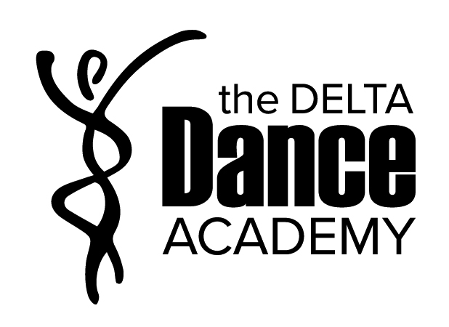
- Guest instructors for different genres of dance
- Field trips: Circus Lab, Professional Dance shows
- Fitness activities
- Dance terminology
- Anatomy & nutrition
- Combos and Stretch

EQUIPMENT & SUPPLIES:

Required Supplies: (Please have all clothing ready for next class, and be ready to dance!)
- Binder with lined paper and a few dividers (we may be able to store these)
- Jazz: Fitted dance wear and black Jazz shoes
- Ballet: Fitted dance wear and pink ballet shoes
- Hip Hop: Sweat pants or comfortable clothing and running shoes

Supplied: (students can keep these)
- All students will select a custom bodysuit in a set colour to be used for performances
- As a group, we will select the rest of our Dance Academy clothing together.
  - Options: hoodies, t-shirts, bags, pens, etc.

ASSESSMENT:
Success in the dance academy relies heavily on the level of effort and participation put in by each dancer throughout the year. It is imperative that students attend regularly and give their all during class time. The goal for all dancers is to improve their skill level by the end of the year, regardless of what that skill level is.

Students’ final grades will be based on the following:
30% Daily self-evaluations (participation)
30% Projects, Assignments & Final portfolio (reflections & personal growth)
40% Performances (solo, small group & large group)

Daily Self-evaluations
Each week students will complete a short self-evaluation on their preparation, attitude, skills & knowledge and intensity. Ms. McMillan will also be assessing daily. At the end of each term we will compile this information into a grade.

Portfolios
At the beginning of the year students will learn how to create their own portfolio website. Throughout the year students will use this space to document their learning (written, photo & video) and reflect on their performances and experiences. At the end of the year students will present their final portfolios and take a look back on their accomplishments from the year.

Performances & Projects
All self-evaluations and performances will be marked using a 4-point rubric like the example below:
Exemplary  A  (100 – 86) | Accomplished  B  (85 – 73) | Developing  +C-  (72 – 50) | Beginning  I / F  (49 – 0)
-Consistently exceptional in all areas  -Above and beyond standards | -Good in all areas  -Consistently meets standards | -Average  -Meets some standards but not others | -below averages  -Unexcused absences and/or missing assignments or performances

Depending on the project or performance, some of the following categories may be assessed:
- Technique, expression, Musicality, choreography, professionalism, choice of music/costume, rehearsal & preparation, etc.

BC Dance Curriculum
To see the complete BC dance curriculum: https://curriculum.gov.bc.ca/curriculum/arts-education/9/courses

